Practicum Final Exam – Even Semester Year 2020/2021
Subject |  |  | COMP6580 - Database Administration |  |  | 
Class | : | BG01 / BI01 |  | Start Date | : 12 June 2021
Lecturer | : | D5878 - Dewi Suryani, S.Kom., M.Eng.  D6198 - Fepri Putra Panghurian, S.Kom., M.T.I. |  | Start Time | : 11:20
Lecturer | : |  |  | End Date | : 12 June 2021
Lecturer | : |  |  | End Time | : 13:20

PERATURAN UJIAN:
Exam Regulations:
- Mahasiswa tidak diperbolehkan berdiskusi dan/atau bekerja sama dengan peserta ujian lainnya
Student is not allowed to discuss and/or work together with other exam participants
- Mahasiswa tidak diperbolehkan untuk membuka dan menyalin dari BUKU atau CATATAN, VIDEO dari pengajar (recording kelas, VBL, Youtube, dsb) dan REFERENSI lainnya
Student isn't allowed to open and copy from any resources such as notes, videos (class recording, VBL, Youtube, etc) and other references
- Mahasiswa tidak diperbolehkan membuka dan menyalin jawaban dari internet (google, stackoverflow, dsb)
Student isn't allowed to open and copy answer from the internet (google, stackoverflow, etc)
- Asisten BERHAK memberi nilai 0 (NOL) bagi peserta ujian yang melakukan segala bentuk kecurangan
Assistant is able to give 0 (ZERO) score for exam participant who does any cheating actions
- Kumpulkan jawaban tepat pada waktunya, apabila terlambat mengumpulkan maka jawaban tidak akan dikoreksi dan nilai mahasiswa adalah 0
Submit the answer on time, if not, then the answer will not be checked, and the students will receive 0 (ZERO)
- Bila Anda tidak membaca peraturan ini, maka Anda dianggap telah membaca dan menyetujuinya
If you have missed to read these regulations, so you are considered to have read and agreed on it



SOFTWARE YANG DIGUNAKAN:
Software will be used:
- SQL Server 2019
- SQL Server Management Studio
- Microsoft Word

FILE YANG DIKUMPULKAN:
File must be collected:
- .sql

PERHATIAN!
Attention!
- Bagi yang mengerjakan tidak sesuai dengan soal, maka akan diberikan nilai NOL (0)
For those who do not work in accordance with the exam case will be marked as ZERO (0)
- Bagi yang mengerjakan tidak sesuai dengan software dan versi yang telah ditetapkan, maka akan tetap dikoreksi dengan software dan versi yang telah ditetapkan
For those who do not work in accordance with the software and specific version will be corrected by the predefined software and version
- Kompres semua jawaban yang akan diunggah. Pastikan format pengumpulan nama file dan ekstensi sesuai dengan format berikut: [NIM]-[NAMA].zip
Compress all file that will be uploaded. Make sure the format for collecting file name and extension according to the following format: [NIM]-[NAME].zip

Soal
Case

gyukOSku

gyukOSku is a new established all you can eat barbeque restaurant in Jakarta. As time goes by, the owner needs detailed information about the meat information and customers to estimate shop’s income. The owner is planning to build a DBMS to support their business activity. As a Database Administrator you are asked to make these following tasks:

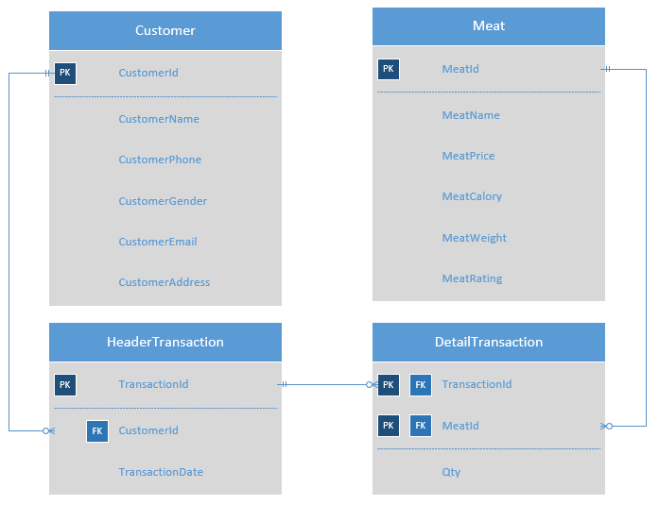

Execute the provided create and insert query file on “gyukOSku” database! (“create+insert.sql”)
- Create a new job with the following detail:
Job Name | gyukOSku Transaction Weekly Report
Owner | System Administrator
Category | Data Collector
Description | Generate weekly report of meat transaction occurrence
Schedule | Occurs every 2 week(s) on Wednesday and Saturday at 02:00:00 AM
Step | - Display MeatId, MeatName, TransactionDate, Purchase Amount (obtained from how many times transaction that occurs for every meat and adding “ time(s)” at the end) from Meat data.  - Save the output in a file named “gyukOSku Report.txt”

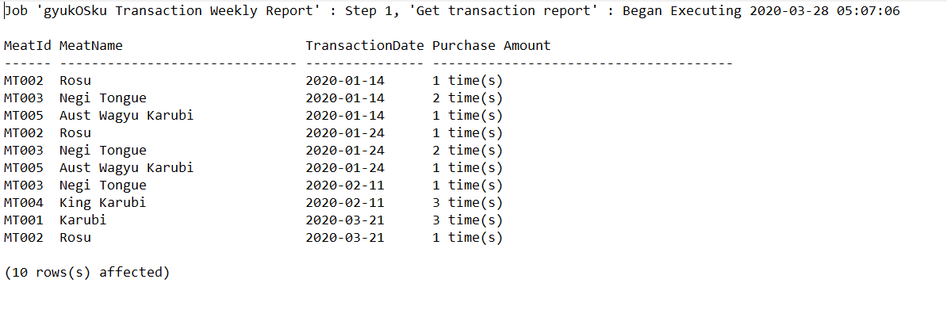

- Create a stored procedure named “DeleteMeat” to delete data in Meat table in accordance with the MeatId inputted by user. The stored procedure parameter is MeatId. Validate MeatId inputted by the user must not exists in TransactionDetail table. If it exists, then show “Meat that has been bought cannot be deleted” message and no row will be deleted. Otherwise, delete that data and show “Selected meat has been removed” message.
Display before the stored procedure is executed:
SELECT * FROM Meat WHERE MeatId ='MT006'

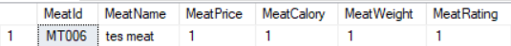
Display after the stored procedure has been executed (success):
EXEC DeleteMeat 'MT006'
SELECT * FROM Meat WHERE MeatId ='MT006'
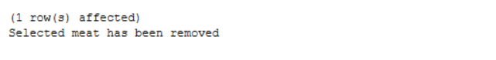
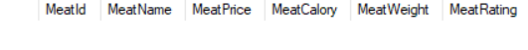
Display if the MeatId exists:
EXEC DeleteMeat 'MT005'

- Create a stored procedure named “TransactionHistory” that contains a cursor to display the list of transaction history in “gyukOSku” database for the selected TransactionId.
    - Each time the stored procedure is executed, it will display the TransactionDate, CustomerName, and CustomerEmail according to TransactionId inputted by user.
    - It will also display the details of the Transaction, including MeatName, MeatPrice, Qty, and TotalPrice (obtained from multiplication of each MeatPrice and Quantity from Transactions). At the end, show Highest Calory (obtained from maximum of the MeatCalory multiplied by the Quantity of the Transactions). Use aggregate to show TotalPrice and Highest Calory. The stored procedure parameter is TransactionId and CustomerId.
EXEC TransactionHistory 'TR001'

Display after the stored procedure is executed:
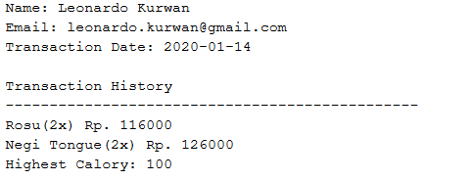

- Create a trigger named “InsertTrigger” to validate data from Meat for every time the user does an insert on the Meat table, validate that the MeatName that will be inserted should not already exists in the Meat table. If it exists, then show “Meat named <inserted MeatName> already exist” message and do not do the insertion. Otherwise, show “Successfully inserted meat” and proceed to insert the meat.
Display after the trigger is executed and meat name already exists:
INSERT INTO Meat VALUES('MT006', 'King Karubi', 1000, 1, 1, 1)
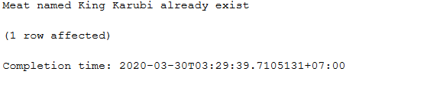
Display after the trigger is executed and meat name does not exist:
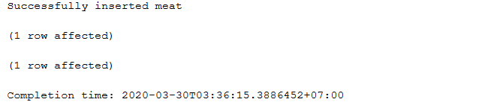
How to generate job script:
- Right click on the job
- Script Job as > Create To > New Query Editor Window > Save as sql
Files need to be collected:
- *.sql
  - Job Task Script
  - Query for number 2, 3, and 4

